

Where is Australia
How is the climate there
How is the inhabitant
What sorts of animals can be found there

Written by: Adel Baledi

Australia

The major parts of Australia consist of dry areas and deserts, but the northern parts of the continent has a tropical climate while the southern parts have a Mediterranean climate. Australia is a big continent and it’s realy hard for Europeans and Americans to understand how desolated it is, for example: the city Perth on the westcoust is probably the most isolated city in the world, the nearest city from there is Adelaide and the distans between them is more then 2100 kilometres or shoud I say 1310 miles.

Australia has a smoth landscape because it’s an old continent that have been grind by wind and water for ages. Nowadays not more then 13% of the hole continent is over 1650 feet, and that’s why Australia is one of the flattest countries on earth.
But Australia has a wonderful coustline that’s about 22812 miles long, and one of the main attractions is The Great Barrier Reef that’s the largest coral-reef system in the world; it’s a system of coral-reefs that’s 1250 miles long from north to south along Queenslands coust.

Australia is known by it’s particular plants and animal life, there is alot of species there that can’t be found any where else. In the dry inland grows scrubs that blooms up for a while after it rained. The forests mostly live in heavy rainfall areas like the north, northeast and southeast parts of Australia. I’m going to tell more about the wild-life on the next page, but first comes some Hard Facts.

Hard Facts

Surface: 7 682 300 km2
Population: 18 520 000
Population growth per year: 1,6 %
Average length of life: Men 74 år, Woman 80 år
Child per fertile women: 1,9
Capital city: Canberra (328 000)
Other big citys: Sydney (3,7milj.), Melbourne (3,2milj.), Adelaide, Perth, Brisbane
Language: English, Australlanguage
Religion: Protestant
Goverment: unionstate, member of the Commonwealth
National day: January the 26:th (the first settleing 1788)
Member of the UN: yes, 1945
Currency: Australian dollar (US $1 = A $1,6
Gross national per capita: 18 893 (US $)
Time: +7 - +9 hours
One years rainfall: aproxematly 635 mm
Average temperature: 14°C
Ability to read and write: 99% of the population

The Wild-Life

There are many species of animals, which are only found in the wild Australia.
Australia is famous for it’s group of animals called marsupials, the common thing with these animals is that they carry their youngs in their pouches. We already know some of these animals; kangaroos and koalas, there are also wombats, possums and wallabies.

Kangaroos
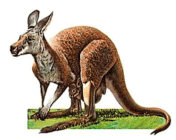
The biggest of all kangaroos is the red giant kangaroo. They only produce one children at a time because they can’t carry any more in their pouches.
All kangaroos have powerful back legs and long narrow hind feet. When the kangaroo is moving slowy, it drops onto all four and uses it’s tail for extra support. But in high speeds it jumps with it’s back legs and uses the tail to balance.

Koalas
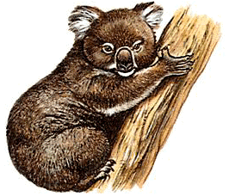
The koala is a soft and round animal with a woollen fur, it’s not longer then 3 feet and has a short tail. Koalas are climbing animals living among the branches of eucalyptus trees in Australia. The koala usualy sleeps for 18 hours a day and are night active. Their main diet is eucalyptus leafs.

Possums
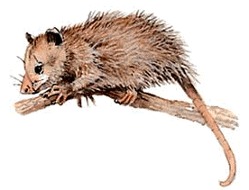
Possums are small animals that looks like ratts but have movments like kangaroos. Every possum has it’s one territory, and they are mostly active at night. It’s hard to write any more information about this animal because we don’t know alot about it, except that they are close to be eradicated.

Wombats
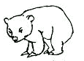
Wombats are pouched mammals that live in borrows, a burrow is a hole in the ground like rabbit holes. Each wombat has several borrows which it sometimes shares with other wombats, but every wombat has its own feeding place, their usual diet is grass, roots of trees and shrubs. Wombats are very similar to the koalas, they are also night active.
The picture isn’t very good, wombats actualy have color, haha.

Geography

Australia is a big continent with alot of fantastical places, it’s positioned in a way that makes it have tropical weather and at the same time have cold raini weather.
Australia is the worlds smallest and isolated continent, and it’s on the opposite side of Europ.
In the earlier days were, Ny Zeeland, Ny Guinea and the islands of the Pacific Ocean a part of Australia. A long time ago the continent was a member of an old ancient continent called Gondwanaland. Australia is divided in eight large parts: Western Australia, Northern Territory, South Australia, Queensland, New South Wales, ACT, Victoria and Tasmania.

Australia
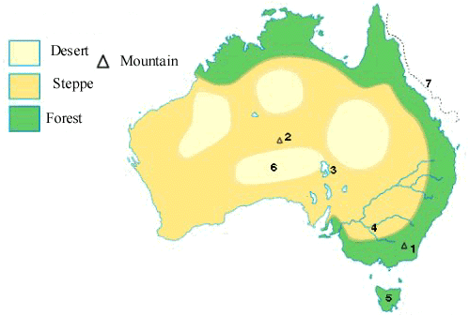
Hard Facts

1 Mount Kosciusco 7 433 feet
2 Ayer’s Rock 1 167 feet
3 Eyre lake 8 075 square miles
4 Murray 1 056 miles
5 Tasmania 42 442 square miles
6 The Australian Desert 2,05 miljon square miles
7 The Great Barrier Reef 1 250 miles long

The Inhabitants

Aborgines
Archaeologists have found traces from life in Australia that are over 40 thousand years old. It’s traces of lifes from the aborgines that probably immigrated from southeast Asian to Australia. There is a theory that says there were 3 immigrant waves that populated Australia.

Nowadays
Australias population is only 18,5 miljon, that’s realy to little for a big continent like Australia. Almost 70% of the population lives in the southeastern parts, where the big citys are. Most of the buildings are built under the last hundred years and that’s not alot different from us in sweden, except for the weather offcourse. In some parts of Australia the people live so far from each other that the children are educated through radio schools and they keep in touch with their teachers through letters.
There are also alot of swedish people there, after the World War Too over 900 people from sweden immigrated to Australia.

